SDC I (IoT) Project Report
on
Automatic Street Light

BACHELOR OF ENGINEERING
in
ARTIFICIAL INTELLIGENCE & MACHINE LEARNING

by
Ch.Narender (160724748103)
Sufiya Maheen (160724748110)
G.Vinodhini (160724748127)

Under the Guidance of
Mujthaba Gulam Muqeeth
Associate Professor, Dept. of CSE


DEPARTMENT OF ARTIFICIAL INTELLIGENCE & MACHINE LEARNING
Methodist College of Engineering and Technology,
King Koti, Abids, Hyderabad-500001.
2025-2026
Methodist College of Engineering and Technology,
King Koti, Abids, Hyderabad-500001,

DEPARTMENT OF ARTIFICIAL INTELLIGENCE & MACHINE LEARNING

DECLARATION BY THE CANDIDATES

We, CH.Narender (160724748103), Sufiya Maheen (160724748110) and G.Vinodhini (160724748127) students of Methodist College of Engineering and Technology, pursuing Bachelor’s degree in Artificial Intelligence & Data Science, hereby declare that this SDC I (IoT) Project report entitled “Automatic street light", carried out under the guidance of Mujthaba Gulam Muqeeth submitted in partial fulfilment of the requirements for the degree of Bachelor of Engineering in Artificial Intelligence & Machine Learning . This is a record work carried out by us and the results embodied in this report have not been reproduced / copied from any source.

Ch.Narender (160724748103)
Sufiya Maheen (160724748110)
G.Vinodhini (160724748127)

Methodist College of Engineering and Technology,
King Koti, Abids, Hyderabad-500001.

Department of Artificial Intelligence & Machine Learning

CERTIFICATE BY THE SUPERVISOR

This is to certify that this SDC I (IoT) Project work entitled “Automatic Street Light ” by Ch.Narender (160724748103), Sufiya Maheen (160724748110) and G.Vinodhini (160724748127) submitted in partial fulfilment of the requirements for the degree of Bachelor of Engineering in Artificial Intelligence & Machine Learning, during the academic year 2025-2026, is a bonafide record of work carried out by them.

Mujthaba Gulam Muqeeth
Date: Associate Professor, Dept. of CSE.

Methodist College of Engineering and Technology,
King Koti, Abids, Hyderabad-500001.

Department of Artificial Intelligence & Machine Learning

CERTIFICATE BY HEAD OF THE DEPARTMENT

This is to certify that this SDC I (IoT) Project work entitled “Automatic Street Light” by Ch.Narender (160724748103), Sufiya Maheen (160724748110) and G.Vinodhini (160724748127) submitted in partial fulfilment of the requirements for the degree of Bachelor of Engineering in Artificial Intelligence & Machine Learning, during the academic year 2025-2026, is a bonafide record of work carried out by them.

Dr. P. LAVANYA,
Professor & Head of the Department.
Date:

Methodist College of Engineering and Technology,
King Koti, Abids, Hyderabad-500001.

Department of Artificial Intelligence & Machine Learning

PROJECT APPROVAL CERTIFICATE

This is to certify that this SDC I (IoT) Project work entitled “Automatic Street Light” by Ch.Narender (160724748103), Sufiya Maheen (160724748110) and G.vinodhini (160724748127) submitted in partial fulfilment of the requirements for the degree of Bachelor of Engineering in Artificial Intelligence & Machine Learning, during the academic year 2025-2026, is a bonafide record of work carried out by them.

INTERNAL EXTERNAL HOD

ACKNOWLEDGEMENT

We would like to express a deep sense of gratitude towards the Dr. Prabhu G. Benakop, Principal, Methodist College of Engineering and Technology, for always being an inspiration and for always encouraging us in every possible way.
We would like to express a deep sense of gratitude towards the Dr. Lakshmipathi Rao, Director, Methodist College of Engineering and Technology, for always being an inspiration and for always encouraging us in every possible way.

Our sincere thanks to Dr. P. Lavanya, Professor and Head of the Department of Computer Science and Engineering, for her valuable guidance and encouragement which has played a major role in the completion of the project and for helping us by being an example of high vision and pushing towards greater limits of achievement.
We would like to express our sincere gratitude to my project guide Mujthaba Gulam Muqeeth, Associate Professor, CSE, for giving us the opportunity to work on this topic. It would never be possible for us to take this project to this level without his innovative ideas and his relentless support and encouragement.
We are indebted to the Department of Computer Science & Engineering and Methodist College of Engineering and Technology for providing us with all the required facility to carry our work in a congenial environment. We extend our gratitude to the CSE Department staff for providing us to the needful time to time whenever requested.
We would like to thank our parents for allowing us to realize our potential, all the support they have provided us over the years was the greatest gift anyone has ever given us and also for teaching us the value of hard work and education. Our parents have offered us with tremendous support and encouragement, thanks to our parents for all the moral support and the amazing opportunities they have given us over the years.



Vision & Mission
VISION
To become a leader in providing Computer Science & Engineering education with emphasis on knowledge and innovation.
MISSION
M1: To offer flexible programs of study with collaborations to suit industry needs
M2: To provide quality education and training through novel pedagogical practices
M3: To Expedite high performance of excellence in teaching, research and innovations.
M4: To impart moral, ethical valued education with social responsibility.

Program Educational Objectives
Graduates of Compute Science and Engineering at Methodist College of Engineering and Technology will be able to:
PEO1: | Apply technical concepts, Analyze, synthesize data to Design and create novel products and solutions for the real-life problems.
PEO2: | Apply the knowledge of Computer Science Engineering to pursue higher education with due consideration to environment and society.
PEO3: | Promote collaborative learning and spirit of team work through multidisciplinary projects
PEO4: | Engage in life-long learning and develop entrepreneurial skills.
Program Specific Outcomes
At the end of 4 years, Compute Science and Engineering graduates at MCET will be able to:
PSO1: | Apply the knowledge of Computer Science and Engineering in various domains like networking and data mining to manage projects in multidisciplinary environments.
PSO2: | Develop software applications with open-ended programming environments.
PSO3: | Design and develop solutions by following standard software engineering principles and implement by using suitable programming languages and platforms

PROGRAM OUTCOMES
PO1: Engineering Knowledge: Apply knowledge of mathematics, natural science, computing, engineering fundamentals and an engineering specialization as specified in WK1 to WK4 respectively to develop to the solution of complex engineering problems.

PO2: Problem Analysis: Identify, formulate, review research literature and analyze complex engineering problems reaching substantiated conclusions with consideration for sustainable development. (WK1 to WK4)

PO3: Design/Development of Solutions: Design creative solutions for complex engineering problems and design/develop systems/components/processes to meet identified needs with consideration for the public health and safety, whole-life cost, net zero carbon, culture, society and environment as required. (WK5)

PO4: Conduct Investigations of Complex Problems: Conduct investigations of complex engineering problems using research-based knowledge including design of experiments, modelling, analysis & interpretation of data to provide valid conclusions. (WK8).

PO5: Engineering Tool Usage: Create, select and apply appropriate techniques, resources and modern engineering & IT tools, including prediction and modelling recognizing their limitations to solve complex engineering problems. (WK2 and WK6)

PO6: The Engineer and The World: Analyze and evaluate societal and environmental aspects while solving complex engineering problems for its impact on sustainability with reference to economy, health, safety, legal framework, culture and environment. (WK1, WK5, and WK7).

PO7: Ethics: Apply ethical principles and commit to professional ethics, human values, diversity and inclusion; adhere to national & international laws. (WK9)

PO8: Individual and Collaborative Team work: Function effectively as an individual, and as a member or leader in diverse/multi-disciplinary teams.

PO9: Communication: Communicate effectively and inclusively within the engineering community and society at large, such as being able to comprehend and write effective reports and design documentation, make effective presentations considering cultural, language, and learning differences

PO10: Project Management and Finance: Apply knowledge and understanding of engineering management principles and economic decision-making and apply these to one’s own work, as a member and leader in a team, and to manage projects and in multidisciplinary environments.
PO11: Life-Long Learning: Recognize the need for, and have the preparation and ability for i) independent and life-long learning ii) adaptability to new and emerging technologies and iii) critical thinking in the broadest context of technological change. (WK8)

S. No. | Title  Table of contents | Page No.
I | Abstract | I
1 | Introduction | 1
1.1 | Background of the Study | 1
1.2 | Need for the System | 2
1.3 | Aim of the Project | 2
1.4 | Objectives
1.5 | Scope of the Project
1.6 | Problem Definition | 3
1.7 | Significance of the Project
2 | Literature Survey | 4
3 | System Analysis | 6
3.1 | Existing System drawbacks
3.2 | Proposed System
3.3 | Functional Requirements | 7
3.4 | Non functional requirements
3.5 | System components
3.6 | Advantages | 8
3.7 | Applications
3.8 | Software requirements
4 | System Design | 9
4.1 | Block Diagram / Circuit Diagram/Architecture
4.2 | Flowchart | 10
5 | Implementation and sample code | 12
6 | Testing | 15
 | Conclusion | 19
 | Future Enhancements | 19
 | Appendix (QR CODE with all project docs in Gdrive) | 20

I. ABSTRACT
The project focuses on modernizing conventional street lighting by tackling major issues such as unnecessary energy consumption, lack of automatic control, and the limitations of manual monitoring. The aim is to design and develop an IoT-Based Automatic Street Light System that can intelligently operate based on real-time environmental conditions. The objective is to create a smart and energy-efficient lighting network that automatically responds to changes in light intensity and detects the movement of vehicles or pedestrians to ensure proper illumination. The methodology involves using IoT sensors to capture surrounding light levels and motion, a microcontroller to process the data and control the switching of lights, and a connected system that ensures smooth automation without human involvement. The findings reveal significant energy savings, improved system reliability, reduced human effort, and enhanced nighttime safety for commuters. The scope of the project extends to highways, residential streets, smart cities, industrial areas, and campuses where intelligent lighting can improve overall efficiency. Overall, the project outcome demonstrates that the IoT-enabled street light system provides a modern, automated, and sustainable approach that enhances visibility, conserves electricity, and supports smart infrastructure development.

I

1.INRODUCTION
Street lighting is an essential part of modern urban infrastructure, ensuring public safety, supporting night-time transportation, and improving overall city life. Proper illumination on roads helps prevent accidents, guides pedestrians and drivers, and enhances security by reducing incidents in dark areas. However, traditional street lighting systems are often inefficient and outdated, leading to unnecessary power consumption and operational difficulties. Most conventional systems rely on manual operation or fixed timers that do not respond to environmental changes, causing lights to remain ON during daylight or fail to turn ON when visibility is low. These limitations result in energy wastage, higher costs, and Reduce the system Reliability To address these challenges, the IoT-Based Automatic Street Lighting System has been introduced. This system uses smart sensors, microcontrollers, and IoT technology to automate street lights based on real-time environmental conditions. By integrating Light Dependent Resistors (LDRs) to detect light intensity and Infrared (IR) sensors to sense movement, the system ensures that lights operate only when necessary. The use of IoT modules like NodeMCU or ESP8266 enables remote monitoring and control, making the system efficient and suitable for smart city development. Overall, this project aims to reduce power consumption, enhance safety, and improve the reliability of street lighting through intelligent automation.
1.1 Background of the Study
The background highlights the growing need for more efficient street lighting systems due to increasing energy costs, urban expansion, and the demand for safer public spaces. Traditional lighting models depend on fixed timers or manual operation, which often fail to adjust to real-time conditions such as weather changes, daylight variation, or traffic flow. These outdated systems lead to wasted electricity and increased maintenance efforts. With advancements in IoT and sensor technologies, it has become possible to implement smart lighting solutions that automatically respond to environmental changes, reduce human involvement, and improve overall efficiency.
1.2 Need for the System
The need for an automated street lighting system arises from the inefficiencies of current manual and timer-based methods. These systems often leave lights ON during the day or fail to turn them ON during low-light conditions, resulting in energy loss and unsafe environments. Human error also contributes to delays in switching lights ON or OFF. Additionally, traditional systems do not adjust lighting based on traffic movement, leading to unnecessary energy consumption in empty roads. Hence, a smart, IoT-driven lighting system is required to ensure real-time control, energy optimization, and enhanced public safety.
1.3 Aim of the Project
The aim of the project is to develop an IOT-Based Automatic Street Light System capable of intelligently controlling street lights by detecting ambient light levels and the movement of vehicles or pedestrians, thereby reducing energy consumption and improving road safety.
1.4 Objectives
The main objectives of the project are:
● To use LDR sensors to detect ambient light intensity
● To use IR sensors for detecting vehicle and pedestrian movement
● To automate the switching of street lights based on real-time conditions
● To reduce energy consumption using intelligent brightness control
● To enable remote monitoring and control using IoT technology
● To improve safety on roads during night-time and low-light conditions
1.5 Scope of the Project
The project scope includes designing an automated lighting system using sensors, microcontrollers, and IoT connectivity. It can be implemented in highways, residential streets, rural areas, university campuses, and smart city projects. The system provides automatic ON/OFF control, dynamic brightness adjustment, and remote monitoring. It can also be expanded by integrating more sensors or connecting multiple units into a centralized smart city network.
1.6 Problem Definition
Traditional street lighting systems face major limitations such as continuous energy wastage, lack of responsiveness to environmental conditions, and dependence on manual operation. Fixed-timer systems often leave lights ON during daytime or fail to illuminate roads when visibility suddenly drops. Manual systems rely on human operation, which leads to delays and inconsistencies. Additionally, existing lights do not adjust brightness based on road usage, causing unnecessary power consumption.
The problem is defined as the need for a smart, automated street lighting solution that can detect ambient light, identify movement, and operate efficiently without human intervention. The system must use IoT and sensor technologies to provide real-time control, reduce energy wastage, and enhance public safety.
1.7 Significance of the Project
The significance of the project lies in its contribution to sustainable urban development. By reducing electricity consumption and minimizing manual work, the system supports energy conservation and operational efficiency. Automatic detection of movement and light ensures that roads remain safely illuminated only when necessary, improving visibility for drivers and pedestrians. IoT-based monitoring helps identify faults quickly and lowers maintenance costs. The project supports the vision of smart cities by providing an intelligent, eco-friendly, and reliable street lighting solution.

2 . LITERATURE SURVEY
IoT-based street lighting has emerged as a key solution for building energy-efficient and smart urban infrastructures. Researchers have explored various methods to automate traditional street lights using sensors, microcontrollers, and wireless communication technologies. Early studies focused on basic automation using LDR and IR sensors to detect light intensity and movement, but these systems lacked advanced features such as adaptive brightness and real-time monitoring. Later works introduced IoT modules like NodeMCU, ESP8266, and LoRa communication to enable remote control, fault detection, and improved efficiency. Several studies also highlighted retrofit approaches to upgrade existing street-light infrastructure without full system replacement, offering a cost-effective path for smart-city development. Despite these advancements, challenges remain in large-scale deployment, network dependency, and handling diverse environmental conditions. This project aims to address these gaps by designing a more reliable and adaptive IoT-based automatic street-light system that enhances energy savings and improves operational performance.
Author / Year | Method / Technique | Dataset Used | Key Findings / Accuracy | Limitations
D. Betteena & S. Fernando (2020) | IoT-based smart street pole system | Real-time environmental data | Enhanced smart-city integration and energy-efficient lighting | Limited scalability for large urban areas
Prashanth S. U., Rakshanraj J. & A. Maria Christina Blessy (2022) | IoT-based smart street lighting | Sensor-based street light dataset | Automated ON/OFF control and reduced energy consumption | Limited fault detection features
Gaurav Kumar Biswas & Hardik (2024) | Retrofit IoT street light system | Legacy street-light infrastructure data | Upgrades traditional lights to smart IoT without full replacement | Depends heavily on existing infrastructure quality
S. Sasidevi & Vasanthi M. (2024) | Intelligent IoT lighting with adaptive brightness | Real-time brightness & fault detection data | Better brightness control and efficient fault management | Higher implementation cost
R. S. Carlos & Rumiasih Rumiasih (2024) | IoT-based automatic street light control | LDR & IR sensor dataset | Accurate night/day detection and motion-based control | Performance may vary in extreme weather

3.SYSTEM ANALYSIS
System analysis helps break down how the existing street-lighting setup works and what improvements the new IoT-based system will bring. This ensures the system becomes smarter, energy-efficient, and fully responsive to environmental conditions.

3.1. Existing System drawbacks (Current Scenario / Problem Definition)
How the Current System Works
Most traditional street lighting systems operate in a manual or time-based manner:
- Lights are turned ON or OFF manually by operators.
- In some places, timers control the lights regardless of actual lighting conditions.
Problems in the Current System
- Manual switching leads to wasted energy, especially when lights stay ON even when not needed.
- Time-based systems fail during weather changes (cloudy days, sudden darkness).
- High operational cost due to human involvement and poor energy management.
- No automatic monitoring, leading to delays in detecting faults.
- Lights often malfunction or stay ON during daytime due to lack of automation.
3.2. Proposed System
To develop an IoT-based smart street lighting system that automatically controls the lights based on real-time environmental conditions and provides remote monitoring.
Key Technologies & Features
- LDR Sensors detect ambient light levels and control street lights.
- IR sensor detects movement/vehicles for adaptive brightness.
- IoT module (NodeMCU/ESP8266) enables cloud monitoring and remote control.
- Energy-efficient LED lights reduce power consumption.
- Automation ensures lights turn ON/OFF without human intervention.

3.3. Functional Requirements
The system should:
- Automatically turn ON street lights during low-light conditions.
- Turn OFF lights automatically during daytime or bright conditions.
- Detect vehicle or pedestrian movement to increase brightness when required.
- Allow remote monitoring and control through IoT dashboards.
- Collect data like light status, energy usage, and fault conditions.
3.4. Non-Functional Requirements
The system must perform with:
- Efficiency: Low power consumption and optimized lighting cycles.
- Reliability: Works continuously in outdoor environments.
- Scalability: Can expand to more streets or poles without redesign.
- Usability: Simple web or mobile interface for authorities.
- Security: Safe data transfer through IoT networks.
3.5. System Components
Input
- LDR sensor: Detects ambient light levels.
- IR sensor: Detects vehicles or pedestrian movement.
Processing
- Microcontroller (Arduino UNO / NodeMCU): Processes sensor data and controls street lights.
- Arduino IDE: Used to write, compile, and upload the program/code to the microcontroller.
- IoT module: Sends and receives data to/from the cloud for monitoring and control.
Output
- Street lights turn ON/OFF or adjust brightness based on sensor input.
- Sends status updates and alerts to the IoT dashboard.
3.6 Advantages
- Energy Saving: Automatically runs lights only when needed.
- Cost Efficient: Reduced electricity and maintenance costs.
- Smart Control: Remote access anytime through IoT dashboards.
- High Automation: Eliminates manual monitoring or switching.
- Adaptive Brightness: Increases brightness only when vehicles pass, saving more energy.
- Fault Detection: Alerts when a street light is malfunctioning.
3.7 Applications
- Smart Cities: Fully automated street lighting for urban areas.
- Highways & Roads: Adaptive lighting based on vehicle movement.
- University/College Campuses: Safe, energy-efficient night-time lighting.
- Residential Areas: Automated lighting in societies or colonies.
- Industrial Areas: Reduces power wastage in large outdoor spaces.
3.8 Software requirements
- Arduino UNO / NodeMCU
- LDR Sensor (Light Detection)
- IR Sensor (Motion Detection)
- LED Street Lamps
- IoT Module (ESP8266/ESP32)
- Power Supply
- Arduino IDE (write, compile, and upload the program)

4.SYSTEM DESIGN
System Design defines the architecture, components, and workflow of the proposed system. It describes how the system will function to achieve its objectives and meet the requirements identified during system analysis.
4.1 Architecture Overview
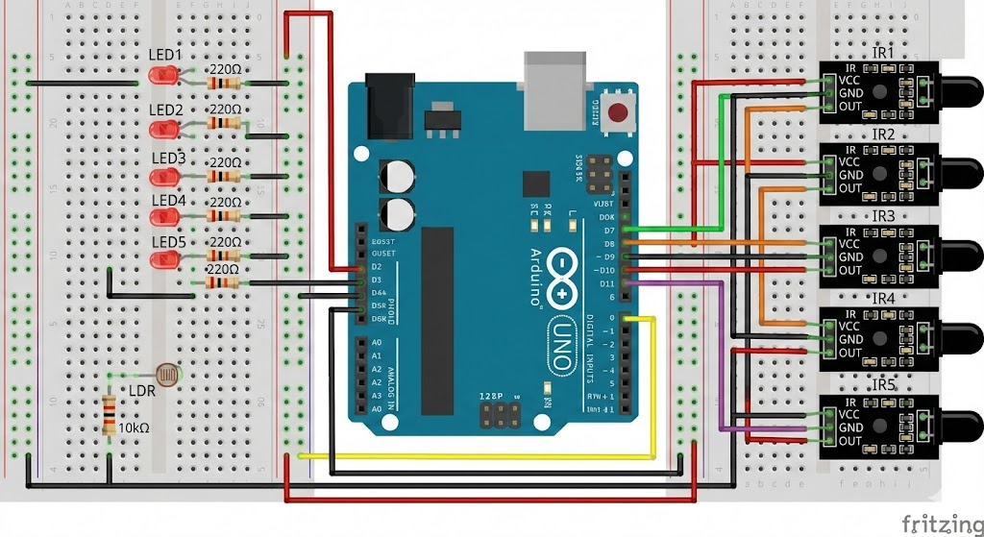
The above figure 1 contains the following
The system follows a modular design with the following main components:
- Arduino UNO
• Central controller of the system.
• Receives inputs from LDR and IR sensors, processes data, and controls LEDs.
• Connected to digital and analog pins for sensor input and LED output.
- LEDs (LED1 – LED5)
• Indicate output states based on sensor readings.
• Connected to Arduino digital pins through 220Ω resistors to limit current.
- LDR (Light Dependent Resistor)
• Measures ambient light intensity.
• Connected in series with a 10kΩ resistor to form a voltage divider.
• Output goes to Arduino analog pin A0.
- Resistor (10kΩ)
• Works with LDR as a pull-down resistor in the voltage divider.
- IR Sensors (IR1 – IR5)
• Detect objects in front of them.
• VCC → 5V, GND → GND, OUT → Arduino digital pins (2, 3, 4, 5, 6).
- Breadboards
• Used for easy connections of LEDs, resistors, LDR, and IR sensors without soldering.
- Jumper Wires
• Connect Arduino, LEDs, sensors, and resistors across breadboards.
4.2 DATA FLOW DIAGRAMS
Provides a detailed step-by-step execution flow showing:
- Initialization — System checks sensors and connections.
- Check ambient light — Measures brightness outside.
- Wait for darkness — Stays idle if it’s bright.
- Turn on lights — Switches ON when dark.
- Detect motion — Senses people or vehicles nearby.
- Increase brightness — Brightens when motion detected.
- Dim lights — Returns to low power when no motion.
- Loop — Repeats automatically.

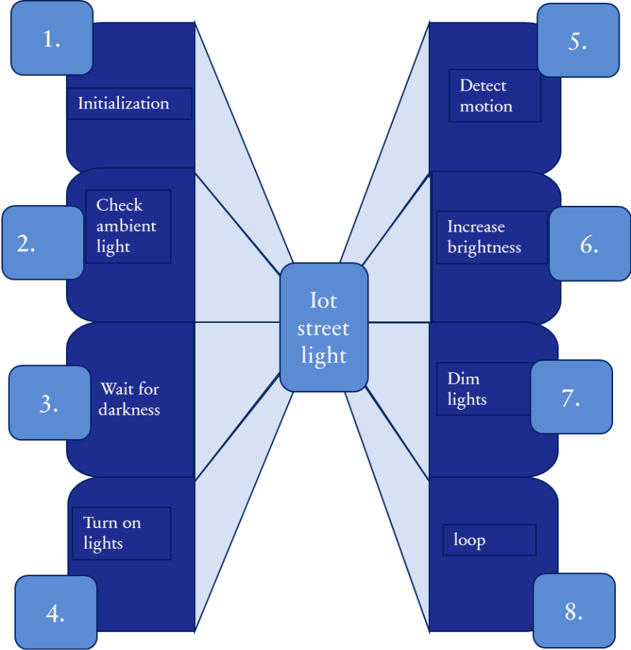
Figure 2: Explanation

5.IMPLEMENTATIONS
The implementation of the IoT automatic street light system involves integrating hardware and software components to achieve intelligent and energy-efficient street lighting. The Arduino UNO acts as the central controller, processing inputs from the LDR (light sensor) and the PIR motion sensor. The LDR continuously measures ambient light levels, while the PIR sensor detects the presence of vehicles or pedestrians. When darkness is detected, the Arduino sends a signal to turn the street lights ON. If motion is detected nearby, the system increases the brightness of the lights to improve visibility. Once no motion is detected for a certain period, the lights return to low power mode to save energy. The system is tested in real-time to ensure that sensors respond accurately, the lights function correctly, and brightness adjusts automatically based on ambient light and motion. This implementation reduces energy consumption, improves road safety, and enables automated street lighting management.

SAMPLE CODE
/ Automatic Street Light using IR + LDR with DIM/BRIGHT control

int LDR = A0;
int irSensor[5] = {A1, A2, A3, A4, A5}; // IR sensor pins
int led[5] = {10, 9, 5, 6, 3}; // LED pins (PWM)

// Change this depending on your IR sensor type:
// true = HIGH means detected (Active HIGH sensor)
// false = LOW means detected (Active LOW sensor)
bool irActiveHigh = false; // most IR modules are active LOW

void setup() {
Serial.begin(9600);
pinMode(LDR, INPUT);

for (int i = 0; i < 5; i++) {
pinMode(irSensor[i], INPUT);
pinMode(led[i], OUTPUT);
}

Serial.println("System Ready...");
}

void loop() {
int ldrValue = analogRead(LDR);
Serial.print("LDR: ");
Serial.println(ldrValue);

int lightThreshold = 500; // Adjust based on your environment

if (ldrValue < lightThreshold) {
// Night Mode
for (int i = 0; i < 5; i++) {
int sensorValue = digitalRead(irSensor[i]);
bool detected = irActiveHigh ? (sensorValue == HIGH) : (sensorValue == LOW);

if (detected) {
analogWrite(led[i], 255); // full brightness when motion detected
} else {
analogWrite(led[i], 60); // dim light otherwise
}
}
} else {
// Day Mode - all lights off
for (int i = 0; i < 5; i++) {
analogWrite(led[i], 0);
}
}

delay(200);
}

6.TESTINGS
- Ambient Light Detection Test: Street lights are monitored to check the response of the LDR sensor to different light levels.
- Motion Detection Test: The PIR sensor is tested to accurately detect vehicles and pedestrians nearby.
- Light Control Functionality: Ensures lights turn ON in darkness and increase brightness when motion is detected.
- Multiple Trials: Various times of day and different motion scenarios are tested to verify consistent operation.
- System Reliability: Observed for response time, sensor sensitivity, and proper functioning during continuous operation.
- Outcome: Confirms that the system automates street lighting, saves energy, and enhances road safety.

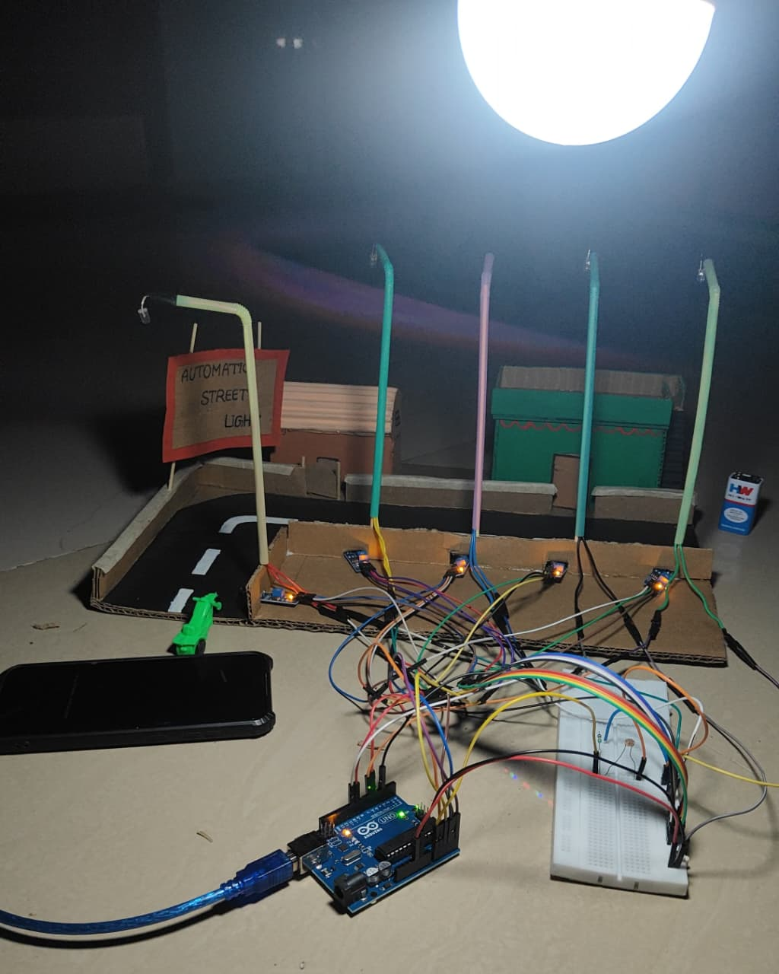
Figure 1: Day Time (street light off)

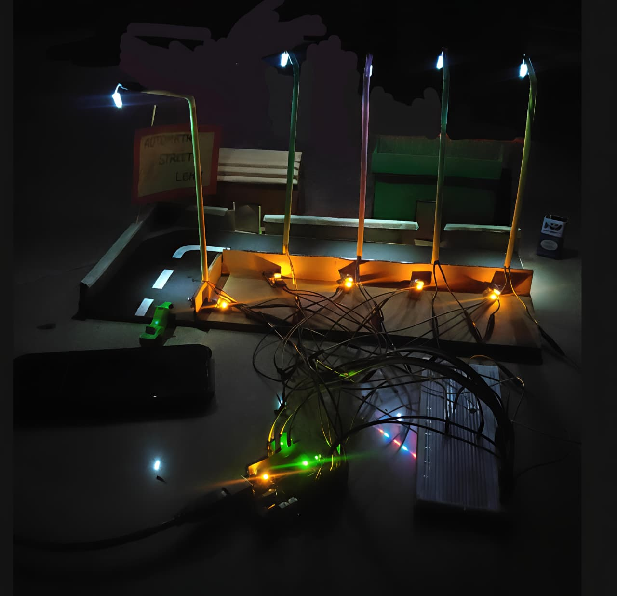
Figure 2: Night Time (street lights on -with low intensity)

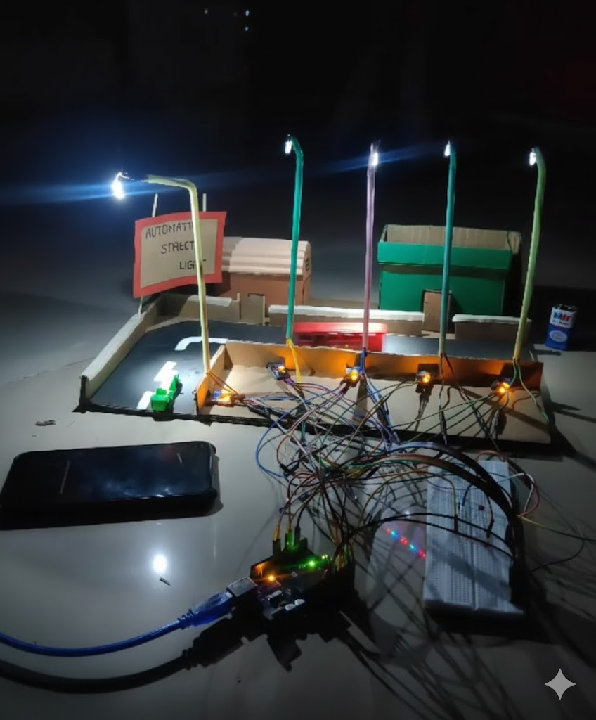
Figure 3: Night Time (Street lights glow at full intensity when a vehicle passes)
)

Conclusion
The system automatically switches street lights ON at night and OFF during the day using IoT-enabled sensors. It intelligently adjusts brightness based on detected movement, saving energy while improving visibility for pedestrians and vehicles. This automation enhances safety, reduces manual effort, and minimizes the risk of human error in street light management. The solution is cost-effective, scalable, and eco-friendly, making it ideal for smart city applications. By promoting sustainable energy usage through intelligent automation, the system contributes to efficient and greener urban infrastructure.

Future Enhancements

  - Enhanced Automation
The system automatically controls lights using both LDR and motion sensors, reducing human effort and errors.
- Smart Brightness Control
Lights increase brightness when motion is detected and dim when idle, maximizing energy savings.
- Real-Time Monitoring
IoT connectivity allows remote monitoring and control of lights through a web or mobile dashboard.
- Energy Efficiency
Power is conserved by activating lights only when needed and turning them off during daylight.
- Cost-Effective Design
Low-cost sensors and microcontrollers (like Arduino) make the system affordable and easy to deploy.
- Scalable System
Additional sensors can be connected to the IoT network to expand the system across multiple streets or cities.



